Template for Evidence(s)
UI GreenMetric Questionnaire

University : ...
Country : ...
Web Address : …

[6] Education and Research (ED)
SAMPLE

[6.6] Total Research Funds (in US Dollars)

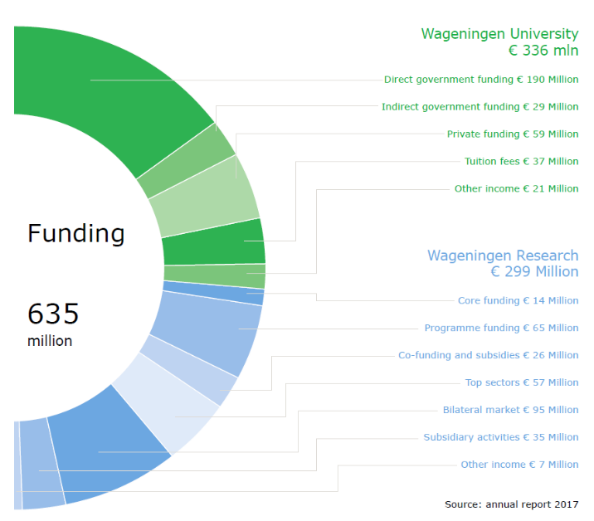
Example of Research Fund (Wageningen University & Research, Netherlands)

Description:
(Please describe total of research funds. The following is an example of the description. You can describe more related items if needed.)

Total research fund in 2022 = ……... US Dollars
Total research fund in 2023 = ……... US Dollars
Total research fund in 2024 = ……... US Dollars
The averaged annum last 3 years of research fund = ……... US Dollars

More over research funding in the Annual report: http://www.wur.nl/en/About-Wageningen/Annual-report-Wageningen-University-Research.htm

Additional evidence link (i.e., for videos, more images, or other files that are not included in this file):

